Assignment---War file @ workstation & deploy on @node, with docker
Use ssh-keygen
id_rsa file
as a private key in Jenkins credential
user should be your service account user (ansible user) and give Id (compulsory) this id is used in jenkinsfile.
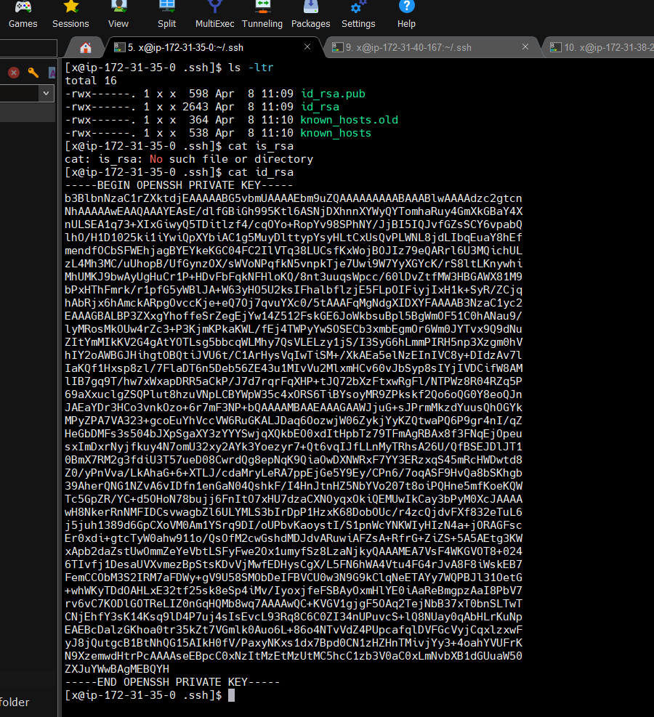
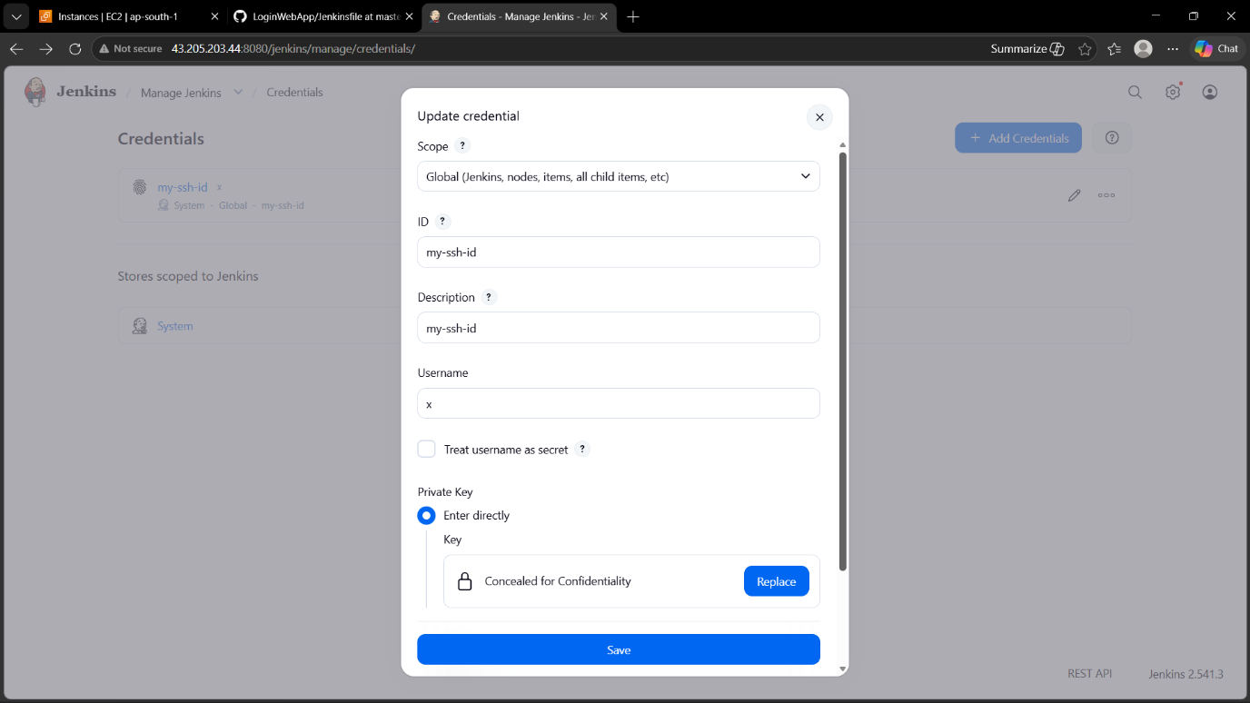

Add ansible user in hosts/inventory file
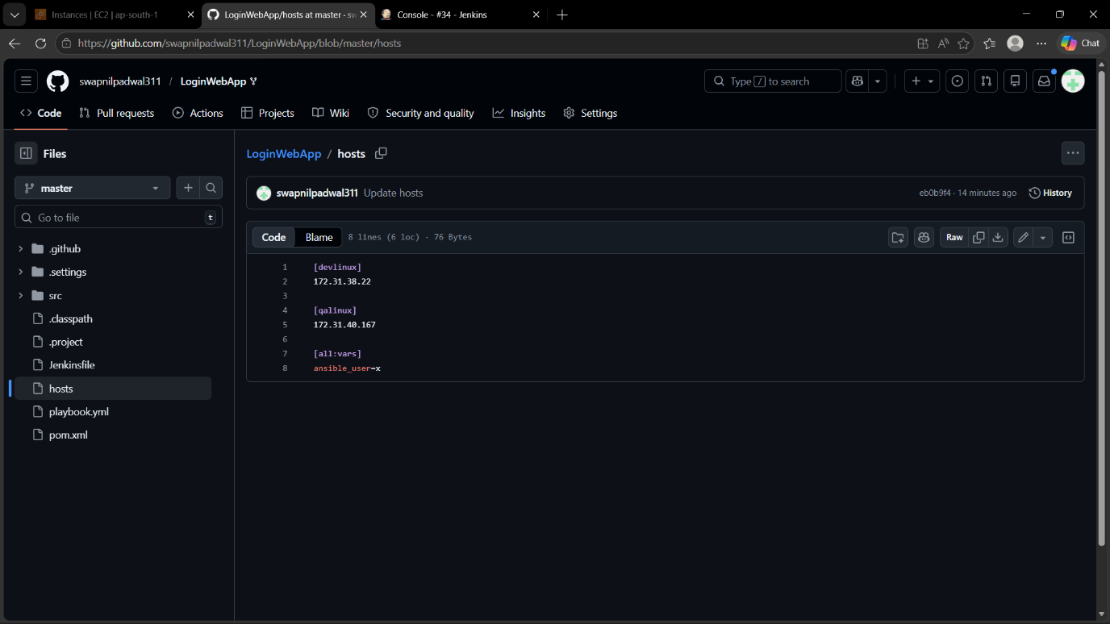

Add user-id (created in credential) in jenkinsfile.
install sshagent plugin in jenkins.
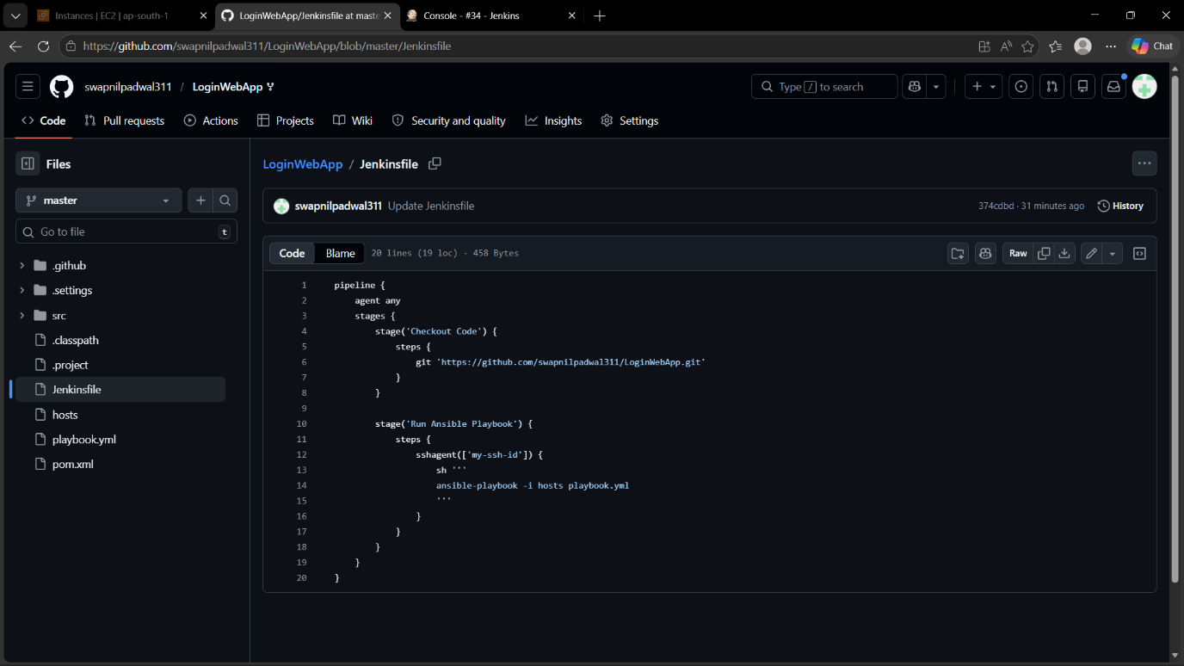

Playbook.yml
